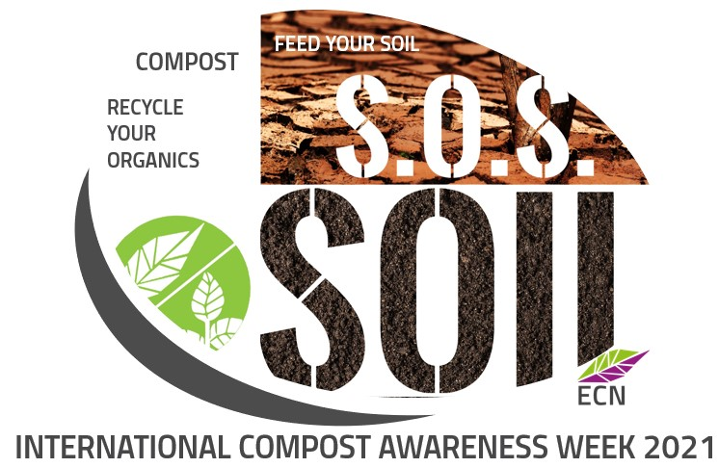**Call for Participants - International Compost Awareness Week**

**Time for proud Europeans to shine and**

**show their own way!**

**After celebrating the World Soil Day in December, the European Compost Network would like to gather its members this Spring – in May 2021 – for the International Compost Awareness Week (ICAW 03-08/05/2021). We aim to become the polar star organisation in Europe for the ICAW.**

We are planning to set up an **online webinar** **(5 May 2021)** to show the best uses of compost with participants from Portugal, Italy, Poland, Norway, Belgium, from North to South and from West to East. **We would like to invite all of you to join an informal webinar and showcase your story by submitting a short video.**

All Europeans should be proud of the achievements of the compost sector which can count on extensive knowledge and pioneering entrepreneurship that are acknowledged as best practices worldwide. It not a coincidence, that the European Union introduced the obligation for all Member States to introduce the separate collection of bio-waste. Who does compost, saves organics in soil and helps the planet!

**What the event will look like?**

It will be a day to celebrate compost *online*, in respect of the safety rules and prevention measures. **We aim to gather 15 to 18 videos from different European countries to showcase the composters’ life in your country.** You could provide examples of composting operations, separate collection of bio-waste, international or local projects you are involved in or also explain how to use compost in agri- and viticulture, in horticulture or in hobby gardening.

Most importantly, since we want to create an informal atmosphere where participants feel comfortable to engage and share their experience, we would like to organize it as an afternoon event from **15:30 h to 16.45 h on 5 May 2021.**

**What should be covered in the video?**

We would like to present real life from separate collection, composting and aneaerobic digestion, from the use of compost in agriculture, winegrowing or horticulture and for hobby gardening. Please show the role of compost in society or advertise your own company. You could make interviews with your customers who explain why they buy compost or with employees who remember how the company innovated since they started to work.

In the video, we would like the participants to answer the following questions:

* Who are you?
* Where are you from? (short explanation of the company, feedstock, process, innovation etc)
* When did you start to work with compost?
* Why is compost important?
* What does the future look like?

**How long will last your video?**

Every video should not last longer than 4 minutes. The video should be in English or in the original language of your country with subtitles in English, if applicable.

**Who will be in the audience?**

There will be ECN members, other businesses, associations, NGOs and interested citizens. We would like that our members could disclose their capacity and show of their added value to the society. After the event, all the videos will be collected and uploaded on ECN website and social networks.

**What do we want from you?**

We warmly invite you to share our invitation, collect good examples from your country and to select at least one video for the event of the European Compost Network. We can guarantee visibility and networking opportunities for all the participants, as well as knowledge exchange in an informal online framework.

**Deadline for submission:** 15 April 2021

**Background**

The International Compost Awareness Week was initiated by the Canadian Composting Council in 1995 and every year is an important occasion for many events to take place and celebrate recycling and compost. Compost is not only a good soil improver and fertilizer but it is a statement of quality, circularity and sustainability.

Every year, during the International Compost Awareness Week, composting organizations (e.g. Canadian Composting Council, US Composting Council, Australian Organics Recycling Organisation) and volunteers engage the population and the authorities of their cities in actions in favour of ecology and recycling around the world.

Recycling plants open their doors to visitors and show the fascinating recycling operations taking place. Many other independent initiatives are organised by producers of compost, who usually set up a small kiosk in front of the supermarkets to sell their product directly to households. The most interested ones can also buy a brand-new composting bin to replace the old one, or to begin with their own home composting for the first time. Composting training courses are organized in public parks or private gardens. Kids can play and learn at the same time.

Link to ECN Member Info 01_2021: https://bit.ly/2PfxCNE